**Test Case 0002**

**System:** Bench

**Description:** Test that the user is deleted from the matching set correctly.

**Severity:** 3

**Instructions**

**Test1**

1. Start the Bench application.
2. Click the button “Login” on the navigation bar.
3. Enter the email “team23project@gmail.com” into the text field labeled “Email address”.
4. Enter the password “12345678” into the field labeled “Password”.
5. Click the button “Login” below the field.
6. After the screen has loaded, there should be a delete button displayed as an “X” on each of the user’s profile panels.
7. Click on the delete button on any of the user profile panels.

**Expected Result:** The selected user profile panel should no longer be present on the “Explore” page.

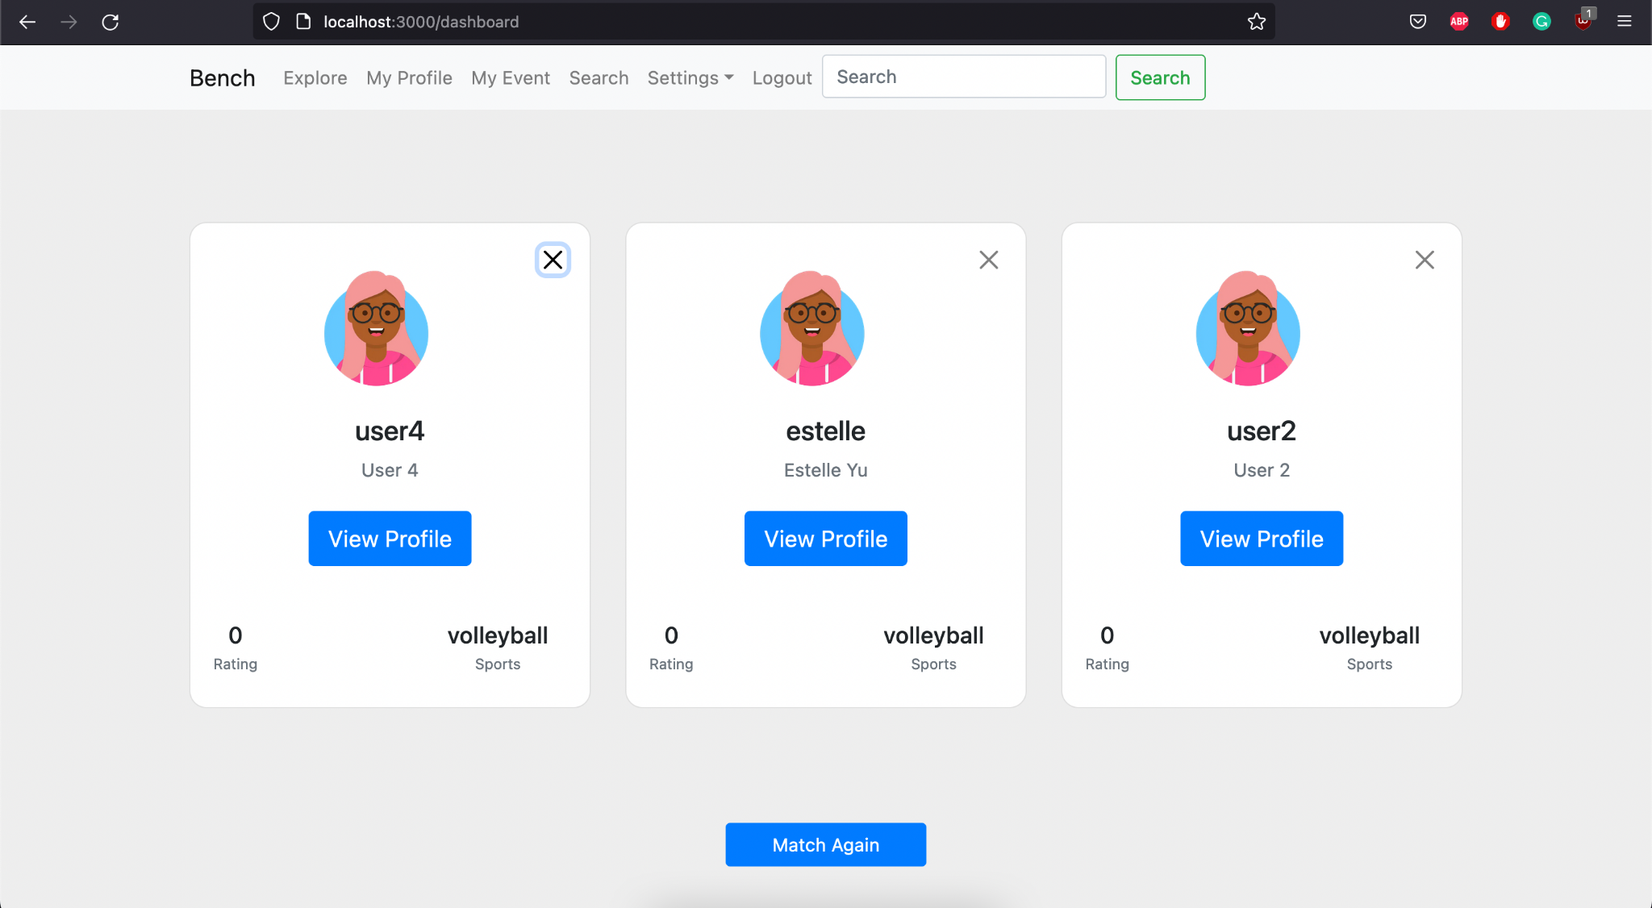

**Test2**

1. Start the Bench application.
2. Click the button “Login” on the navigation bar.
3. Enter the email “team23project@gmail.com” into the text field labeled “Email address”.
4. Enter the password “12345678” into the field labeled “Password”.
5. Click the button “Login” below the field.
6. After the screen has loaded, click on the delete button displayed as an “X” on any of the user profile panels.

**Expected Result:** A new user’s panel should appear to fill in the spot of the removed user panel.



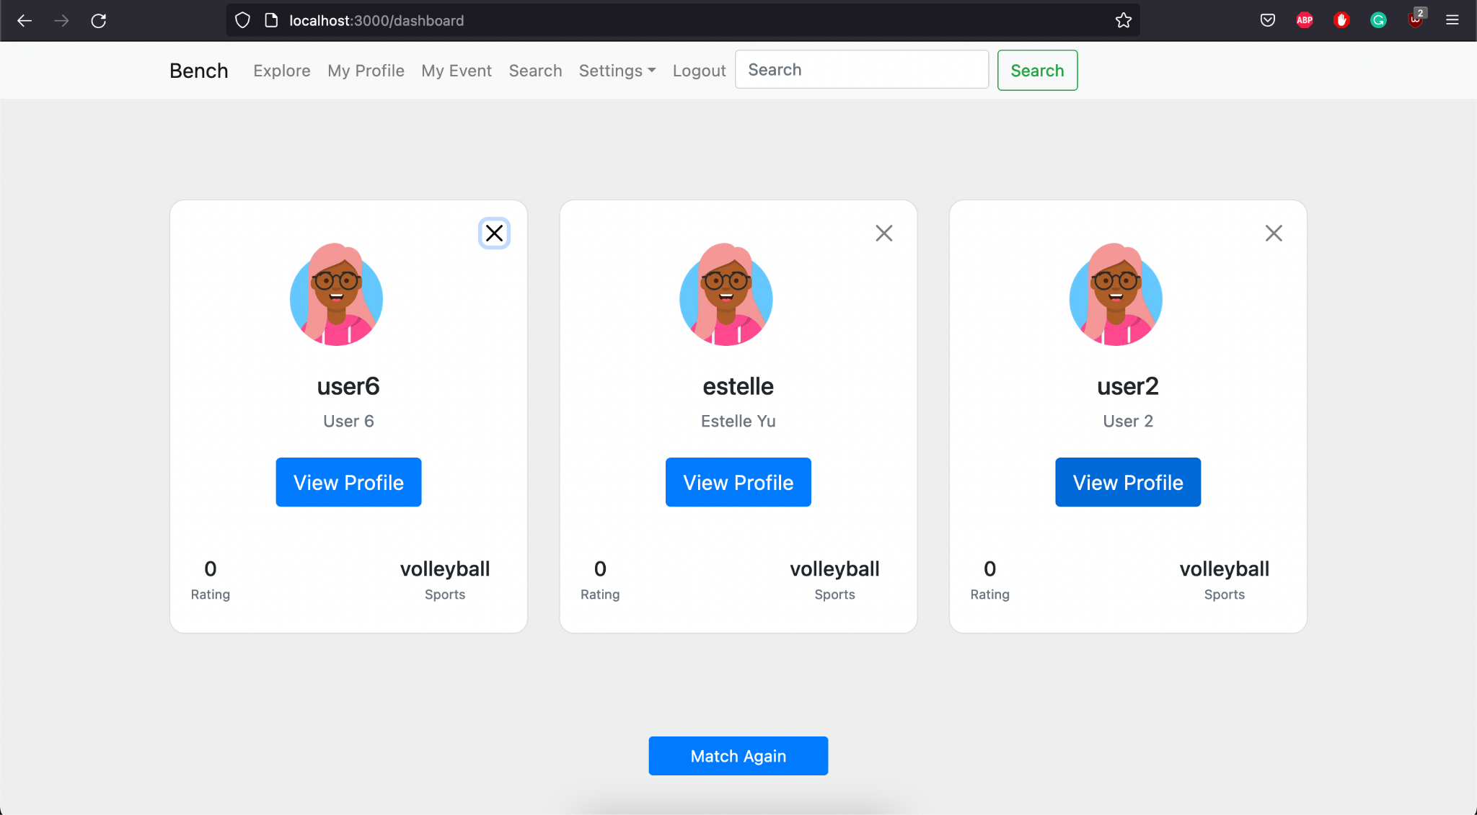

**Test 3**

1. Start the Bench application.
2. Click the button “Login” on the navigation bar.
3. Enter the email “team23project@gmail.com” into the text field labeled “Email address”.
4. Enter the password “12345678” into the field labeled “Password”.
5. Click the button “Login” below the field.
6. After the screen has loaded, click on the delete button displayed as an “X” on any of the user profile panels.

**Expected Result:** the change in the “Explore” page is shown immediately in response to the click.



